**Date:4/4/24 EXPERIMENT 11**

**Name:Rithika shree**

**21R231**

**Path Planning Algorithm using ROS**

**Aim:**

To learn the Path Planning Algorithms (A* and Dijkstra’s algorithms).

**Software/ Package Used:**

<https://realitybytes.blog/2018/08/17/graph-based-path-planning-a/amp/>

<https://github.com/SakshayMahna/Robotics-Playground/tree/main/turtlebot3_ws>.

ROS

**Programs:**

**A* algorithm :**

**CODE:**

#! /usr/bin/env python

import matplotlib.pyplot as plt

from copy import deepcopy

COLOR_MAP = (0, 8)

class PathPlanner:

def __init__(self, grid, visual=False):

self.grid = grid

self.visual = visual

self.heuristic = None

self.goal_node = None

def calc_heuristic(self):

row = len(self.grid)

col = len(self.grid[0])

self.heuristic = [[0 for x in range(col)] for y in range(row)]

for i in range(row):

for j in range(col):

row_diff = abs(i - self.goal_node[0])

col_diff = abs(j - self.goal_node[1])

self.heuristic[i][j] = int(abs(row_diff - col_diff) + min(row_diff, col_diff) * 2)

print ("Heuristic:")

for i in range(len(self.heuristic)):

print self.heuristic[i]

def a_star(self, start_cart, goal_cart):

goal = [goal_cart[1], goal_cart[0]]

self.goal_node = goal

init = [start_cart[1], start_cart[0]]

# Calculate the Heuristic for the map

self.calc_heuristic()

print init, goal

if self.visual:

viz_map = deepcopy(self.grid)

fig = plt.figure(figsize=(12, 12))

ax = fig.add_subplot(111)

ax.set_title('Occupancy Grid')

plt.xticks(visible=False)

plt.yticks(visible=False)

plt.imshow(viz_map, origin='upper', interpolation='none', clim=COLOR_MAP)

ax.set_aspect('equal')

plt.pause(2)

viz_map[init[0]][init[1]] = 5 # Place Start Node

viz_map[goal[0]][goal[1]] = 6

plt.imshow(viz_map, origin='upper', interpolation='none', clim=COLOR_MAP)

plt.pause(2)

# Different move/search direction options:

delta = [[-1, 0], # go up

[0, -1], # go left

[1, 0], # go down

[0, 1]] # go right

delta_name = ['^ ', '< ', 'v ', '> ']

# If you wish to use diagonals:

# delta = [[-1, 0], # go up

# [0, -1], # go left

# [1, 0], # go down

# [0, 1], # go right

# [-1, -1], # upper left

# [1, -1], # lower left

# [-1, 1], # upper right

# [1, 1]] # lower right

# delta_name = ['^ ', '< ', 'v ', '> ', 'UL', 'LL', 'UR', 'LR']

# Heavily used from some of the A* Examples by Sebastian Thrun:

closed = [[0 for col in range(len(self.grid[0]))] for row in range(len(self.grid))]

shortest_path = [[' ' for _ in range(len(self.grid[0]))] for _ in range(len(self.grid))]

closed[init[0]][init[1]] = 1

expand = [[-1 for col in range(len(self.grid[0]))] for row in range(len(self.grid))]

delta_tracker = [[-1 for _ in range(len(self.grid[0]))] for _ in range(len(self.grid))]

cost = 1

x = init[0]

y = init[1]

g = 0

f = g + self.heuristic[x][y]

open = [[f, g, x, y]]

found = False # flag that is set when search is complete

resign = False # flag set if we can't find expand

count = 0

while not found and not resign:

if len(open) == 0:

resign = True

if self.visual:

plt.text(2, 10, s="No path found...", fontsize=18, style='oblique', ha='center',

va='top')

plt.imshow(viz_map, origin='upper', interpolation='none', clim=COLOR_MAP)

plt.pause(5)

return -1

else:

open.sort()

open.reverse()

next = open.pop()

x = next[2]

y = next[3]

g = next[1]

expand[x][y] = count

count += 1

if x == goal[0] and y == goal[1]:

found = True

if self.visual:

viz_map[goal[0]][goal[1]] = 7

plt.text(2, 10, s="Goal found!", fontsize=18, style='oblique', ha='center',

va='top')

plt.imshow(viz_map,origin='upper',interpolation='none', clim=COLOR_MAP)

plt.pause(2)

else:

for i in range(len(delta)):

x2 = x + delta[i][0]

y2 = y + delta[i][1]

if len(self.grid) > x2 >= 0 <= y2 < len(self.grid[0]):

if closed[x2][y2] == 0 and self.grid[x2][y2] == 0:

g2 = g + cost

f = g2 + self.heuristic[x2][y2]

open.append([f, g2, x2, y2])

closed[x2][y2] = 1

delta_tracker[x2][y2] = i

if self.visual:

viz_map[x2][y2] = 3

plt.imshow(viz_map,origin='upper',interpolation='none',

clim=COLOR_MAP)

plt.pause(.5)

current_x = goal[0]

current_y = goal[1]

shortest_path[current_x][current_y] = '* '

full_path = []

while current_x != init[0] or current_y != init[1]:

previous_x = current_x - delta[delta_tracker[current_x][current_y]][0]

previous_y = current_y - delta[delta_tracker[current_x][current_y]][1]

shortest_path[previous_x][previous_y] =

delta_name[delta_tracker[current_x][current_y]]

full_path.append((current_x, current_y))

current_x = previous_x

current_y = previous_y

full_path.reverse()

print "Found the goal in {} iterations.".format(count)

print "full_path: ", full_path[:-1]

for i in range(len(shortest_path)):

print shortest_path[i]

if self.visual:

for node in full_path:

viz_map[node[0]][node[1]] = 7

plt.imshow(viz_map, origin='upper', interpolation='none', clim=COLOR_MAP)

plt.pause(.5)

# Animate reaching goal:

viz_map[goal[0]][goal[1]] = 8

plt.imshow(viz_map, origin='upper', interpolation='none', clim=COLOR_MAP)

plt.pause(5)

return init, full_path[:-1]

if __name__ == '__main__':

test_grid = [[0, 0, 0, 0, 0, 0],

[0, 1, 1, 1, 1, 0],

[0, 1, 0, 0, 0, 0],

[0, 1, 0, 0, 0, 0],

[0, 1, 0, 0, 0, 0],

[0, 1, 0, 0, 0, 0],

[0, 1, 0, 0, 0, 0],

[0, 1, 0, 0, 1, 0]]

test_start = [0, 0] # [x, y]

test_goal = [5, 7] # [x, y]

# test_grid = [[0, 0, 0, 0, 0, 0, 0, 0],

# [0, 0, 0, 0, 0, 0, 0, 0],

# [0, 0, 0, 0, 0, 0, 0, 0],

# [1, 1, 1, 1, 1, 1, 1, 1],

# [1, 0, 0, 1, 1, 0, 0, 1],

# [1, 0, 0, 1, 1, 0, 0, 1],

# [1, 0, 0, 1, 1, 0, 0, 1],

# [1, 0, 0, 0, 0, 0, 0, 1],

# [1, 0, 0, 0, 0, 0, 0, 1],

# [1, 0, 0, 0, 0, 0, 0, 1],

# [1, 0, 0, 0, 0, 0, 0, 1],

# [1, 0, 0, 0, 0, 0, 0, 1],

# [1, 1, 1, 1, 1, 1, 1, 1]]

# test_start = [2, 4] # [x, y]

# test_goal = [6, 11] # [x, y]

# Create an instance of the PathPlanner class:

test_planner = PathPlanner(test_grid, True)

# Plan a path.

test_planner.a_star(test_start, test_goal)

**COMMANDS:**

* git clone https://github.com/atomoclast/realitybytes_blogposts.git
* /realitybytes_blogposts/pathplanning/
* cd pathplanning
* pathplanning$ chmod +x a_star.py
* 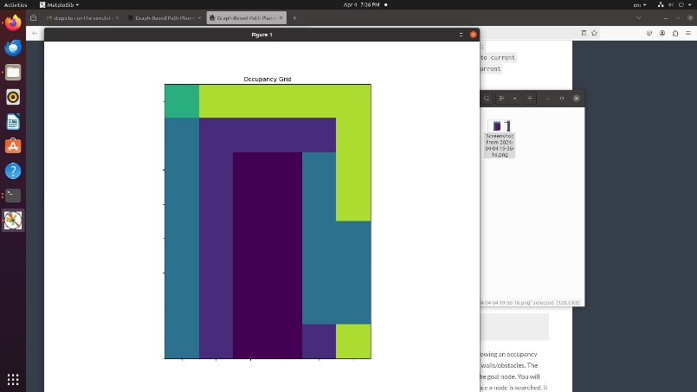python3 a_star.py

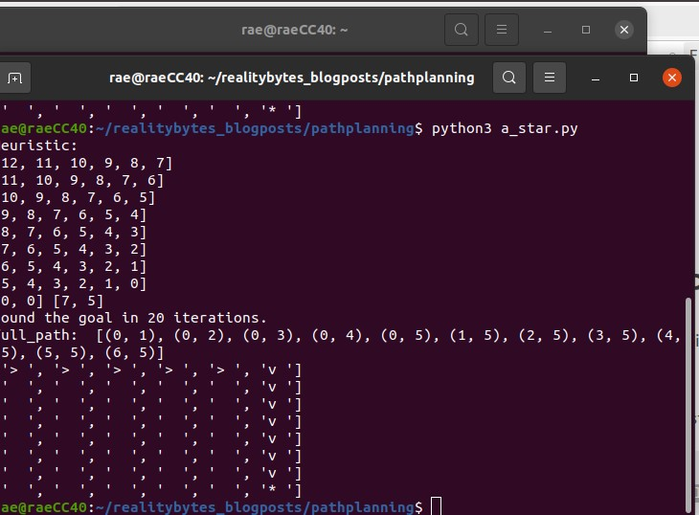

**Dijistra’s Algorithm**

**CODE:**

from __future__ import print_function

import numpy as np

import math

import matplotlib.pyplot as plt

import pprint

def dijkstras(occupancy_map, x_spacing, y_spacing, start, goal):

DEBUG = False

VISUAL = True

colormapval = (0, 8)

goal_found = False

# Setup Map Visualizations:

if VISUAL == True:

viz_map=occupancy_map

fig = plt.figure(figsize=(12,12))

ax = fig.add_subplot(111)

ax.set_title('Occupancy Grid')

plt.xticks(visible=False)

plt.yticks(visible=False)

plt.imshow(viz_map, origin='upper', interpolation='none', clim=colormapval)

ax.set_aspect('equal')

plt.pause(2)

# We will use this delta function to search surrounding nodes.

delta = [[-1, 0], # go up

[0, -1], # go left

[1, 0], # go down

[0, 1]] # go right

# Each node on the map "costs" 1 step to reach.

cost = 1

# Convert numpy array of map to list of map, makes it easier to search.

occ_map = occupancy_map.tolist()

if DEBUG == True:

print("occ_map: ")

pprint.pprint(occ_map)

# Converge start and goal positions to map indices.

x = int(math.ceil((start.item(0) / x_spacing) - 0.5)) # startingx

y = int(math.ceil((start.item(1) / y_spacing) - 0.5)) # startingy

goalX = int(math.ceil((goal.item(0) / x_spacing) - 0.5))

goalY = int(math.ceil((goal.item(1) / y_spacing) - 0.5))

print("Start Pose: ", x, y)

print("Goal Pose: ", goalX, goalY)

# Make a map to keep track of all the nodes and their cost distance values.

possible_nodes = [[0 for row in range(len(occ_map[0]))] for col in range(len(occ_map))]

row = y

col = x

# Show the starting node and goal node.

# 5 looks similar to S and 6 looks similar to G.

possible_nodes[row][col] = 5

if VISUAL == True:

viz_map[row][col] = 5

viz_map[goalY][goalX] = 6

plt.imshow(viz_map, origin='upper', interpolation='none', clim=colormapval)

plt.pause(2)

if DEBUG == True:

print("Possible Nodes: ")

pprint.pprint(possible_nodes)

g_value = 0

frontier_nodes = [(g_value, col, row)] # dist, x, y

searched_nodes = []

parent_node = {} # Dictionary that Maps {child node : parent node}

loopcount = 0

while len(frontier_nodes) != 0:

if DEBUG == True:

"\n>>>>>>>>>>>>LOOP COUNT: ", loopcount, "\n"

frontier_nodes.sort(reverse=True) #sort from shortest distance to farthest

current_node = frontier_nodes.pop()

if DEBUG == True:

print("current_node: ", current_node)

print("frontier nodes: ", searched_nodes)

if current_node[1] == goalX and current_node[2] == goalY:

print("Goal found!")

goal_found = True

if VISUAL == True:

plt.text(2, 10, s="Goal found!", fontsize=18, style='oblique', ha='center', va='top')

plt.imshow(viz_map, origin='upper', interpolation='none', clim=colormapval)

plt.pause(2)

break

g_value, col, row = current_node

# Check surrounding neighbors.

for i in delta:

possible_expansion_x = col + i[0]

possible_expansion_y = row + i[1]

valid_expansion = 0 <= possible_expansion_y < len(occupancy_map[0]) and 0 <=

possible_expansion_x < len(occ_map)

if DEBUG == True:

print("Current expansion Node: ", possible_expansion_x, possible_expansion_y)

if valid_expansion:

try:

unsearched_node =

possible_nodes[possible_expansion_y][possible_expansion_x] == 0

open_node = occ_map[possible_expansion_y][possible_expansion_x] == 0

if DEBUG == True:

print("Check Open or Wall: ",

occ_map[possible_expansion_y][possible_expansion_x])

except:

unsearched_node = False

open_node = False

if unsearched_node and open_node:

possible_nodes[possible_expansion_y][possible_expansion_x] = 3

possible_node = (g_value + cost, possible_expansion_x, possible_expansion_y)

frontier_nodes.append(possible_node)

if DEBUG == True:

print("frontier_nodes:", frontier_nodes)

if VISUAL == True:

viz_map[possible_expansion_y][possible_expansion_x] = 3

plt.imshow(viz_map, origin='upper', interpolation='none', clim=colormapval)

plt.pause(.5)

# This now builds parent/child relationship

parent_node[possible_node] = current_node

if DEBUG == True:

print("Parent Node: \n", parent_node)

print("While Possible Nodes: ")

pprint.pprint(possible_nodes)

loopcount = loopcount+1

if goal_found == True:

print("Generating path...")

route = []

child_node = current_node

while child_node in parent_node:

route.append(parent_node[child_node])

child_node = parent_node[child_node]

route.sort()

# route back to metric units:

if DEBUG == True:

print("Route: ", route)

if VISUAL == True:

for i in range(0, len(route)):

viz_map[route[i][2]][route[i][1]] = 7

plt.imshow(viz_map, origin='upper', interpolation='none', clim=colormapval)

plt.pause(.5)

viz_map[goalY][goalX] = 7

plt.imshow(viz_map, origin='upper', interpolation='none', clim=colormapval)

plt.pause(5)

path = []

position = [start.item(0), start.item(1)] # Starting point passed in by function

path.append(position) # Add it to the list for the path

for i in range(0, len(route)):

position = [round((route[i][1]+0.5)*x_spacing, 3), round((route[i][2]+0.5)*y_spacing,

3)]

path.append(position)

position = [goal.item(0), goal.item(1)]

path.append(position)

print("Path: ")

pprint.pprint(path)

# Convert to numpy array and return.

path = np.array(path)

return path

else:

if VISUAL == True:

plt.text(2, 10, s="No path found...", fontsize=18, style='oblique', ha='center', va='top')

plt.imshow(viz_map, origin='upper', interpolation='none', clim=colormapval)

plt.pause(5)

return False

def test():

test_map1 = np.array([

[1, 1, 1, 1, 1, 1, 1, 1],

[1, 0, 0, 0, 0, 0, 0, 1],

[1, 0, 0, 0, 0, 0, 0, 1],

[1, 0, 0, 0, 0, 0, 0, 1],

[1, 0, 0, 0, 0, 0, 0, 1],

[1, 0, 0, 0, 0, 0, 0, 1],

[1, 0, 0, 0, 0, 0, 0, 1],

[1, 0, 0, 0, 0, 0, 0, 1],

[1, 0, 0, 0, 0, 0, 0, 1],

[1, 1, 1, 1, 1, 1, 1, 1]])

x_spacing1 = 0.13

y_spacing1 = 0.2

start1 = np.array([[0.3], [0.3], [0]])

goal1 = np.array([[0.6], [1], [0]])

path1 = dijkstras(test_map1,x_spacing1,y_spacing1,start1,goal1)

true_path1 = np.array([

[0.3, 0.3], [0.325, 0.3], [0.325, 0.5],[0.325, 0.7], [0.325, 0.9], [0.325, 1.1],[0.455, 1.1],

[0.585, 1.1], [0.6, 1.0] ])

if np.array_equal(path1,true_path1):

print("Path 1 passes")

test_map2 = np.array([ [0, 0, 0, 0, 0, 0, 0, 0], [0, 0, 0, 0, 0, 0, 0, 0], [0, 0, 0, 0, 0, 0, 0, 0], [1,

1, 1, 1, 1, 1, 1, 1], [1, 0, 0, 1, 1, 0, 0, 1], [1, 0, 0, 1, 1, 0, 0, 1], [1, 0, 0, 1, 1, 0, 0, 1], [1, 0, 0,

0, 0, 0, 0, 1], [1, 0, 0, 0, 0, 0, 0, 1], [1, 1, 1, 1, 1, 1, 1, 1]])

start2 = np.array([[0.5], [1.0], [1.5707963267948966]])

goal2 = np.array([[1.1], [0.9], [-1.5707963267948966]])

x_spacing2 = 0.2

y_spacing2 = 0.2

path2 = dijkstras(test_map2,x_spacing2,y_spacing2,start2,goal2)

true_path2 = np.array([[ 0.5, 1.0], # [2, 5]

[ 0.5, 1.1], # [2, 5]

[ 0.5, 1.3], # [2, 6]

[ 0.5, 1.5], # [2, 7]

[ 0.7, 1.5], # [3, 7]

[ 0.9, 1.5], # [4, 7]

[ 1.1, 1.5], # [5, 7]

[ 1.1, 1.3], # [5, 6]

[ 1.1, 1.1], # [5, 5]

[ 1.1, 0.9] # [5, 4]

])

if np.array_equal(path2,true_path2):

print("Path 2 passes")

test_map3 = np.array([

[1, 1, 1, 1, 1, 1, 1, 1],

[1, 0, 0, 0, 0, 0, 0, 1],

[1, 0, 0, 0, 0, 0, 0, 1],

[1, 0, 0, 0, 0, 0, 0, 1],

[1, 1, 1, 1, 1, 1, 1, 1],

[1, 0, 0, 0, 0, 0, 0, 1],

[1, 0, 0, 0, 0, 0, 0, 1],

[1, 0, 0, 0, 0, 0, 0, 1],

[1, 0, 0, 0, 0, 0, 0, 1],

[1, 1, 1, 1, 1, 1, 1, 1]])

x_spacing3 = 0.13

y_spacing3 = 0.2

start3 = np.array([[0.3], [0.3], [0]])

goal3 = np.array([[0.6], [1], [0]])

path3 = dijkstras(test_map3, x_spacing3, y_spacing3, start3,goal3)

if path3 == False:

print("Path 3 passes")

def main():

test()

if __name__ == '__main__':

main()

**COMMANDS:**

* git clone https://github.com/atomoclast/realitybytes_blogposts.git
* /realitybytes_blogposts/pathplanning/
* cd pathplanning
* pathplanning$ chmod +x dijkstra.py
* 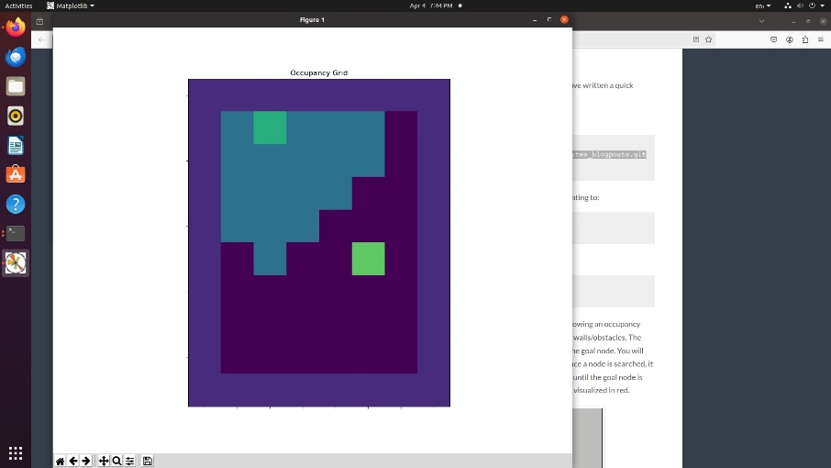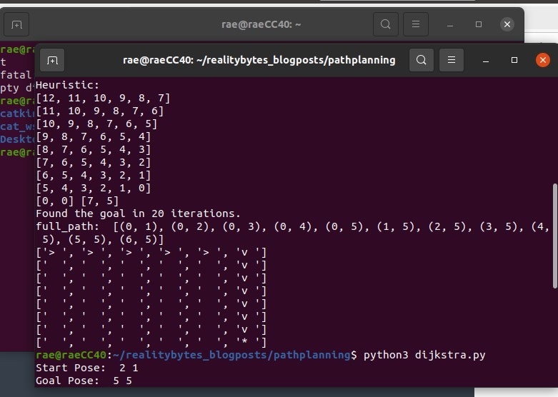python3 dijkstra.py

**a)PATH PLANNING**

#!/usr/bin/env python

import rospy

from pp_msgs.srv import PathPlanningPlugin, PathPlanningPluginResponse

from geometry_msgs.msg import Twist

from gridviz import GridViz

from algorithms.dijkstra import dijkstra

from algorithms.astar import astar

from algorithms.greedy import greedy

from algorithms.q_learning import q_learning

from algorithms.lpastar import lpastar

previous_plan_variables = None

def make_plan(req):

Callback function used by the service server to process

requests from clients. It returns a msg of type PathPlanningPluginResponse

global previous_plan_variables

# costmap as 1-D array representation

costmap = req.costmap_ros

# number of columns in the occupancy grid

width = req.width

# number of rows in the occupancy grid

height = req.height

start_index = req.start

goal_index = req.goal

# side of each grid map square in meters

resolution = 0.05

# origin of grid map

origin = [-10, -10, 0]

viz = GridViz(costmap, resolution, origin, start_index, goal_index, width)

# time statistics

start_time = rospy.Time.now()

# calculate the shortes path

path, previous_plan_variables = lpastar(start_index, goal_index, width, height, costmap, resolution, origin, viz, previous_plan_variables)

if not path:

rospy.logwarn("No path returned by the path algorithm")

path = []

else:

execution_time = rospy.Time.now() - start_time

print("\n")

rospy.loginfo('++++++++ Path Planning execution metrics ++++++++')

rospy.loginfo('Total execution time: %s seconds', str(execution_time.to_sec()))

rospy.loginfo('++++++++++++++++++++++++++++++++++++++++++++')

print("\n")

rospy.loginfo('Path sent to navigation stack')

resp = PathPlanningPluginResponse()

resp.plan = path

return resp

def clean_shutdown():

cmd_vel.publish(Twist())

rospy.sleep(1)

if __name__ == '__main__':

rospy.init_node('path_planning_service_server', log_level=rospy.INFO, anonymous=False)

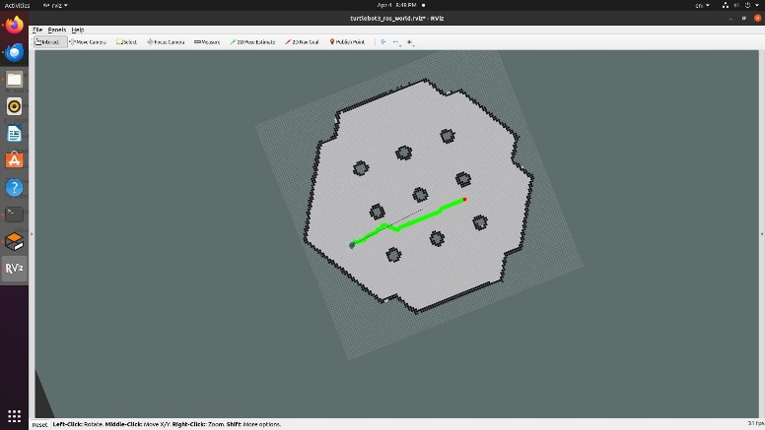make_plan_service = rospy.Service("/move_base/SrvClientPlugin/make_plan", PathPlanningPlugin, make_plan)

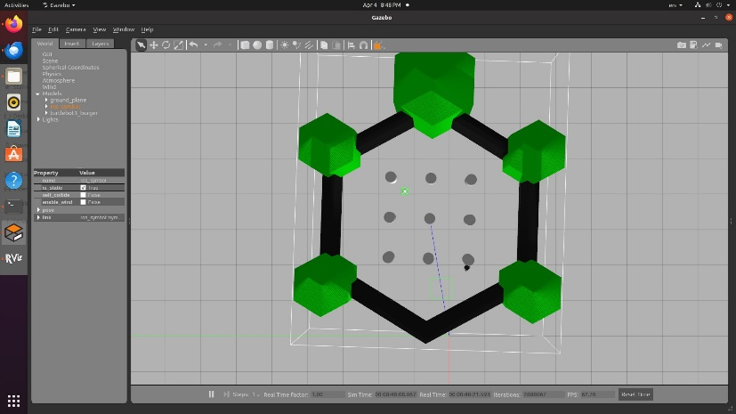

**b)A* ALGORITHM**

#! /usr/bin/env python3

import rospy

from math import sqrt

from algorithms.neighbors import find_neighbors

def euclidean_distance(index, goal_index, width):

""" Heuristic Function for A Star algorithm"""

index_x = index % width

index_y = int(index / width)

goal_x = goal_index % width

goal_y = int(goal_index / width)

distance = (index_x - goal_x) ** 2 + (index_y - goal_y) ** 2

return sqrt(distance)

def astar(start_index, goal_index, width, height, costmap, resolution, origin, grid_viz, previous_plan_variables):

'''

Performs A Star shortest path algorithm search on a costmap with a given start and goal node

'''

# create an open_list

open_list = []

# set to hold already processed nodes

closed_list = set()

# dict for mapping children to parent

parents = dict()

# dict for mapping g costs (travel costs) to nodes

g_costs = dict()

# dict for mapping f costs (heuristic + travel) to nodes

f_costs = dict()

# set the start's node g_cost and f_cost

g_costs[start_index] = 0

f_costs[start_index] = 0

# add start node to open list

start_cost = 0 + euclidean_distance(start_index, goal_index, width)

open_list.append([start_index, start_cost])

shortest_path = []

path_found = False

rospy.loginfo('A Star: Done with initialization')

# Main loop, executes as long as there are still nodes inside open_list

while open_list:

# sort open_list according to the lowest 'g_cost' value (second element of each sublist)

open_list.sort(key = lambda x: x[1])

# extract the first element (the one with the lowest 'g_cost' value)

current_node = open_list.pop(0)[0]

# Close current_node to prevent from visting it again

closed_list.add(current_node)

# Optional: visualize closed nodes

grid_viz.set_color(current_node,"pale yellow")

# If current_node is the goal, exit the main loop

if current_node == goal_index:

path_found = True

break

# Get neighbors of current_node

neighbors = find_neighbors(current_node, width, height, costmap, resolution)

# Loop neighbors

for neighbor_index, step_cost in neighbors:

# Check if the neighbor has already been visited

if neighbor_index in closed_list:

continue

# calculate g_cost of neighbour considering it is reached through current_node

g_cost = g_costs[current_node] + step_cost

h_cost = euclidean_distance(neighbor_index, goal_index, width)

f_cost = g_cost + h_cost

# Check if the neighbor is in open_list

in_open_list = False

for idx, element in enumerate(open_list):

if element[0] == neighbor_index:

in_open_list = True

break

# CASE 1: neighbor already in open_list

if in_open_list:

if f_cost < f_costs[neighbor_index]:

# Update the node's g_cost and f_cost

g_costs[neighbor_index] = g_cost

f_costs[neighbor_index] = f_cost

parents[neighbor_index] = current_node

# Update the node's g_cost inside open_list

open_list[idx] = [neighbor_index, f_cost]

# CASE 2: neighbor not in open_list

else:

# Set the node's g_cost and f_cost

g_costs[neighbor_index] = g_cost

f_costs[neighbor_index] = f_cost

parents[neighbor_index] = current_node

# Add neighbor to open_list

open_list.append([neighbor_index, f_cost])

# Optional: visualize frontier

grid_viz.set_color(neighbor_index,'orange')

rospy.loginfo('AStar: Done traversing nodes in open_list')

if not path_found:

rospy.logwarn('AStar: No path found!')

return shortest_path

# Reconstruct path by working backwards from target

if path_found:

node = goal_index

shortest_path.append(goal_index)

while node != start_index:

shortest_path.append(node)

# get next node

node = parents[node]

# reverse list

shortest_path = shortest_path[::-1]

rospy.loginfo('AStar: Done reconstructing path')

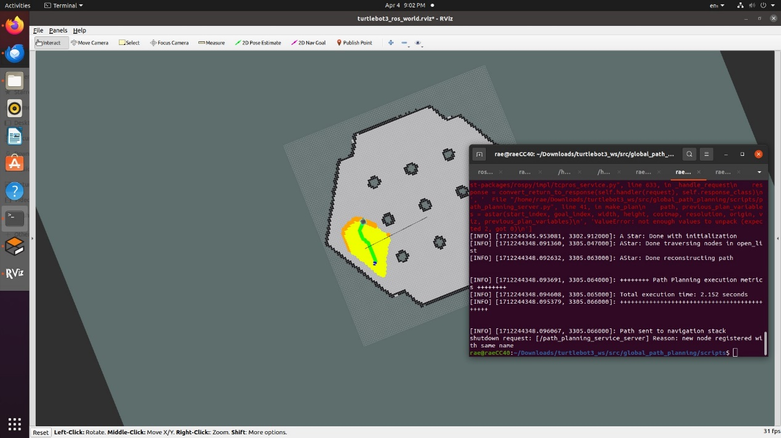

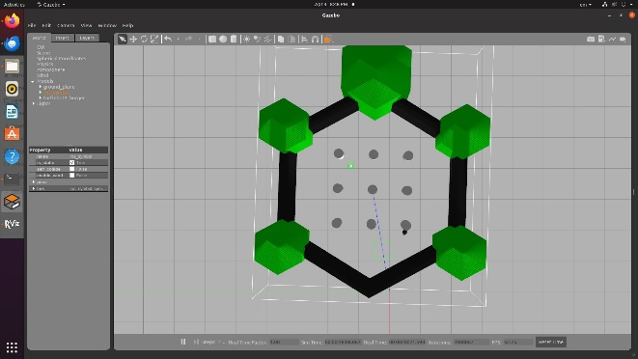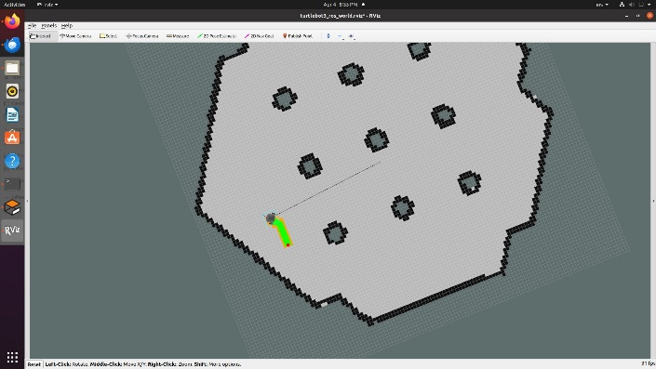

**c)D STAR**

#! /usr/bin/env python3

"""

Dijkstra's algorithm path planning exercise solution

Author: Roberto Zegers R.

Copyright: Copyright (c) 2020, Roberto Zegers R.

License: BSD-3-Clause

Date: Nov 30, 2020

Usage: roslaunch unit2_pp unit2_solution.launch

"""

import rospy

**from algorithms.neighbors import find_neighbors**

**def dijkstra(start_index, goal_index, width, height, costmap, resolution, origin, grid_viz, previous_plan_variables):**

'''

**Performs Dijkstra's shortes path algorithm search on a costmap with a given start and goal node**

'''

# create an open_list

open_list = []

# set to hold already processed nodes

closed_list = set()

**# dict for mapping children to parent**

parents = dict()

# dict for mapping g costs (travel costs) to nodes

g_costs = dict()

# set the start's node g_cost

g_costs[start_index] = 0

# add start node to open list

open_list.append([start_index, 0])

shortest_path = []

path_found = False

rospy.loginfo('Dijkstra: Done with initialization')

# Main loop, executes as long as there are still nodes inside open_list

while open_list:

# sort open_list according to the lowest 'g_cost' value (second element of each sublist)

open_list.sort(key = lambda x: x[1])

# extract the first element (the one with the lowest 'g_cost' value)

current_node = open_list.pop(0)[0]

# Close current_node to prevent from visting it again

**closed_list.add(current_node)**

# Optional: visualize closed nodes

grid_viz.set_color(current_node,"pale yellow")

# If current_node is the goal, exit the main loop

if current_node == goal_index:

path_found = True

break

**# Get neighbors of current_node**

neighbors = find_neighbors(current_node, width, height, costmap, resolution)

# Loop neighbors

for neighbor_index, step_cost in neighbors:

# Check if the neighbor has already been visited

**if neighbor_index in closed_list:**

continue

# calculate g_cost of neighbour considering it is reached through current_node

g_cost = g_costs[current_node] + step_cost

# Check if the neighbor is in open_list

in_open_list = False

for idx, element in enumerate(open_list):

if element[0] == neighbor_index:

in_open_list = True

break

# CASE 1: neighbor already in open_list

if in_open_list:

if g_cost < g_costs[neighbor_index]:

# Update the node's g_cost inside g_costs

g_costs[neighbor_index] = g_cost

parents[neighbor_index] = current_node

# Update the node's g_cost inside open_list

open_list[idx] = [neighbor_index, g_cost]

# CASE 2: neighbor not in open_list

else:

# Set the node's g_cost inside g_costs

g_costs[neighbor_index] = g_cost

parents[neighbor_index] = current_node

# Add neighbor to open_list

open_list.append([neighbor_index, g_cost])

# Optional: visualize frontier

grid_viz.set_color(neighbor_index,'orange')

rospy.loginfo('Dijkstra: Done traversing nodes in open_list')

if not path_found:

rospy.logwarn('Dijkstra: No path found!')

return shortest_path

# Reconstruct path by working backwards from target

if path_found:

node = goal_index

shortest_path.append(goal_index)

while node != start_index:

shortest_path.append(node)

# get next node

node = parents[node]

# reverse list

shortest_path = shortest_path[::-1]

rospy.loginfo('Dijkstra: Done reconstructing path')

return shortest_path, None

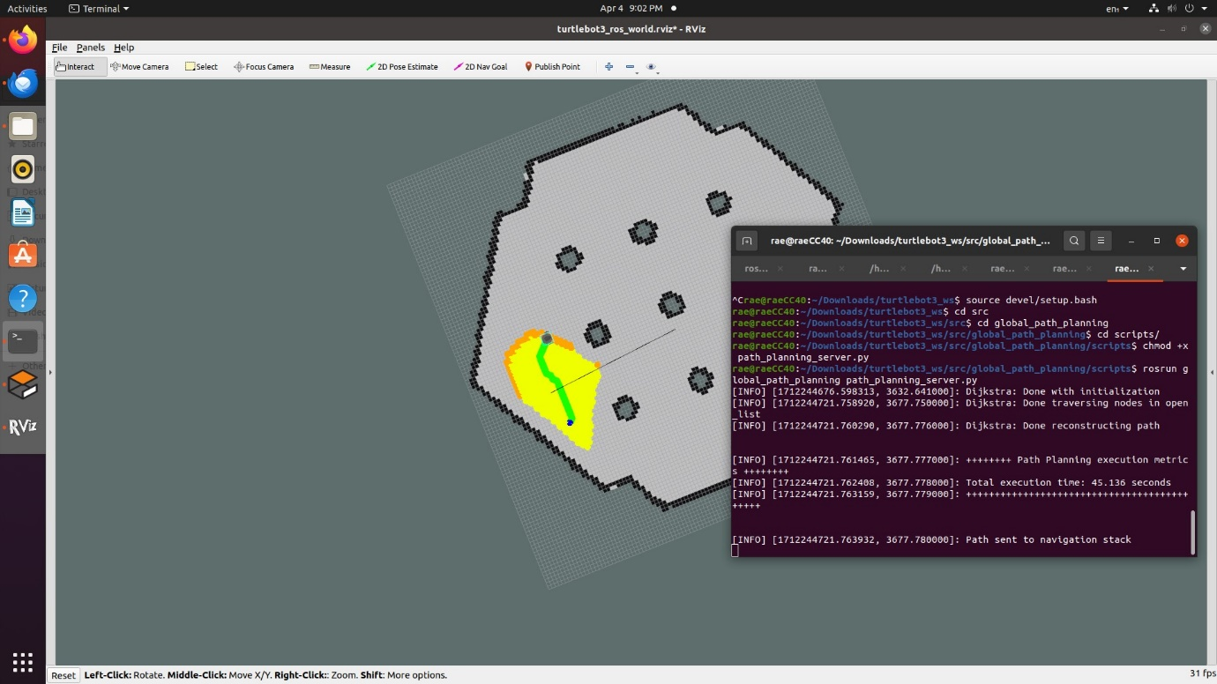

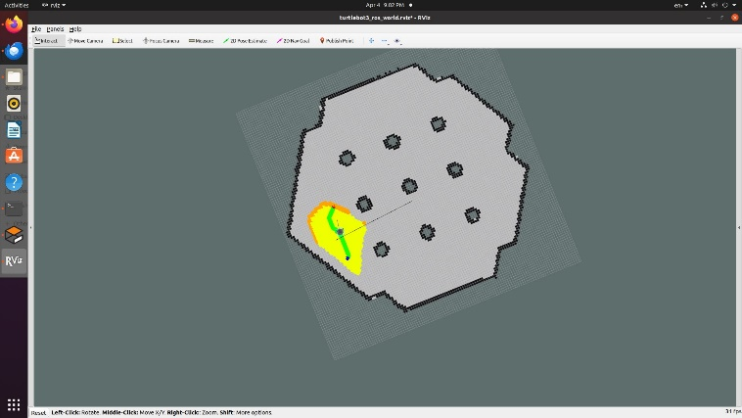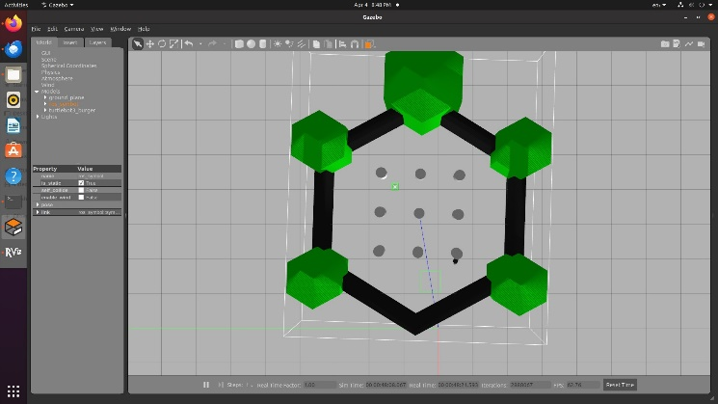

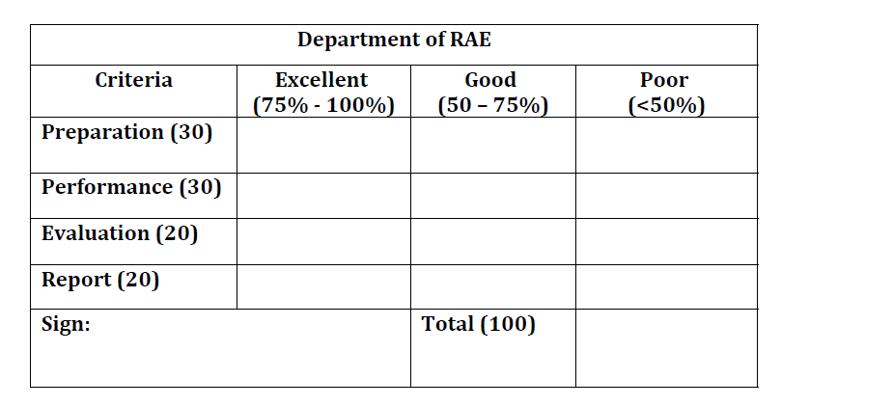

**Result:**

The Path Planning algorithms were learnt using ROS.